AI ASSISTED CODING

ASSIGNMENT 4.3

Name: G.Gopi Chand

batch no: 11

hall ticket no:2403a51237

Table of Contents

1. Task 1 – Zero-shot: Leap Year

2. Task 2 – One-shot: cm → inches

3. Task 3 – Few-shot: Format name

4. Task 4 – Vowel Counter

5. Task 5 – Few-shot: Count lines in file

6. Conclusion

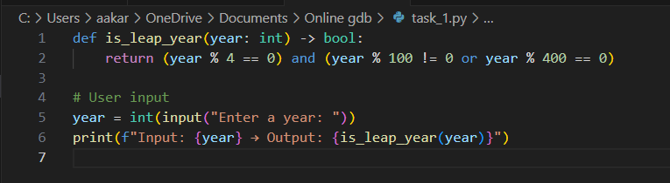Task 1 — Zero-shot: Leap Year

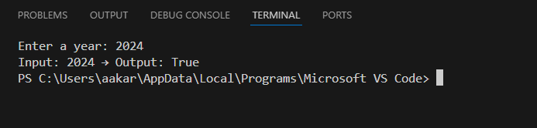Output :

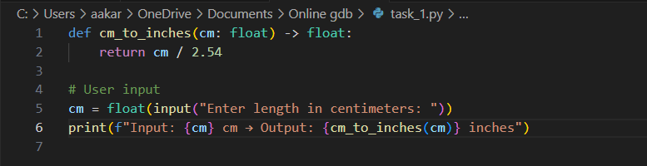Task 2 — One-shot: cm → inches

Output :

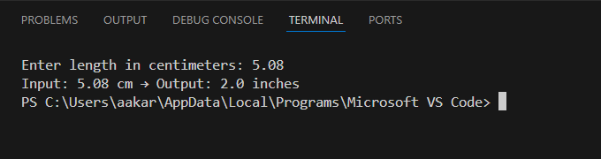

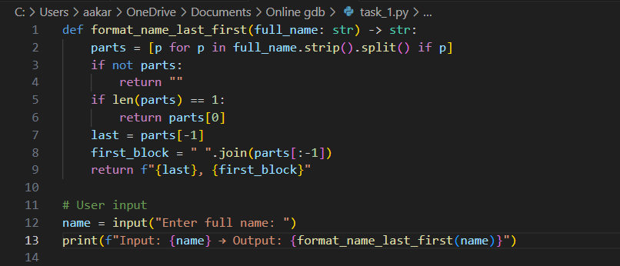Task 3 — Few-shot: Format name

Output :

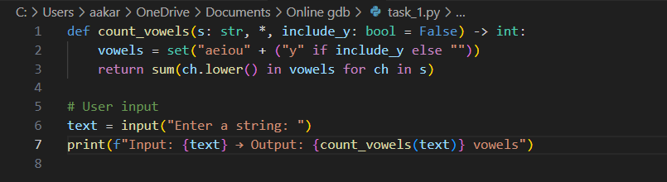Task 4 — Vowel Counter

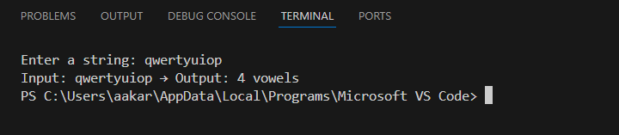Output :

Task 5 — Few-shot: Count lines in file

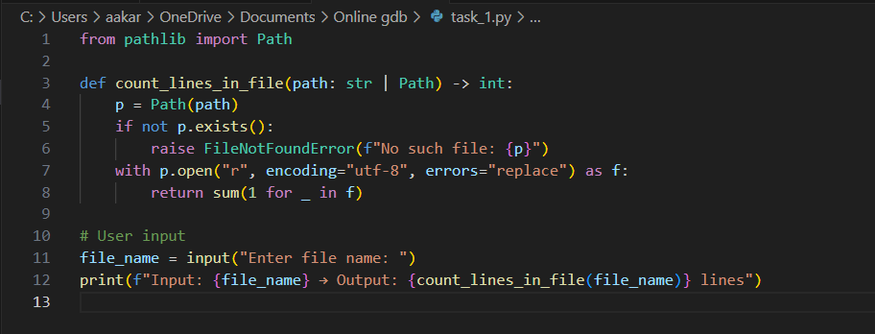

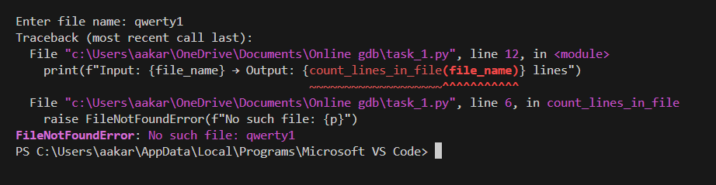Output :